Question 1: OLS Estimation

The Ordinary Least Squares (OLS) approach to multiple linear regression was introduced by Gauss in 1794. The OLS procedure is the simplest type of estimation procedure used in statistical analyses. However, in order to benefit from the well-behaved properties of an OLS estimate, a number of assumptions must be satisfied.
Linear regression is the most basic and commonly used predictive analysis. Regression estimates are used to describe data and to explain the relationship between one dependent variable and one or more independent variables.
At the center of the regression analysis is the task of fitting a single line through a scatter plot. The simplest form with one dependent and one independent variable is defined by the formula y = c + b*x, where y = estimated dependent, c = constant, b = regression coefficients, and x = independent variable.
Sometimes the dependent variable is also called a criterion variable, endogenous variable, prognostic variable, or regressand. The independent variables are also called exogenous variables, predictor variables or regressors.
The idea of the method of least squares is to determine (c, b) so that it minimizes the sum of the squares of the errors, namely
(c + bx1 − y1)² + (c + bx2 − y2) ² + (c + bx3 − y3) ²
In general, for an overdetermined m × n system Ax = b, what Gauss and Legendre discovered is that there are solutions x minimizing
||Ax – b||²
and that these solutions are given by the square n × n system
A^{T}Ax = A^{T}b.

finally
B = (x^{T}x) ⁻¹x^{T}y

% Drop all varibales
clear all; clc;
cd('C:\Temp');

% Loading the data to matlab
[data,countries] = xlsread('AssignmentData.xlsx','A2:D190');
le = data(:,1);
pci = data(:,3);
lpci = log10(pci);

% Createing scatter plot
figure(1);
scatter(lpci, le);
title('The relationship between per capita income and life expectancy');
xlabel('Log10(Per capita income)');
ylabel('Life expectancy');

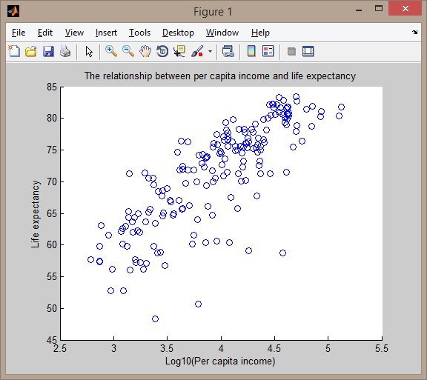

% OLS parameter estimates
Y = le;
n = length(lpci);
X = ones(n,1);
X(:,2)=lpci;
B = inv(X'*X)*X'*Y;
B = B';
'Coefficients b0 b1'
disp(B);

Coefficients b0 b1
24.2783 11.9105
Life expectancy = 24.2783 + 11.9105 * Log10(Per capita income)

% Regression line
b0 = B(1,1);
b1 = B(1,2);
p = [b1 b0];
y_le = polyval(p,lpci);

figure(2);
scatter(lpci, le);
hold on;
plot(lpci, y_le,'r');
title('The relationship between per capita income and life expectancy');
xlabel('Log10(Per capita income)');
ylabel('Life expectancy');
legend('Empirical data','Regression line');
hold off;

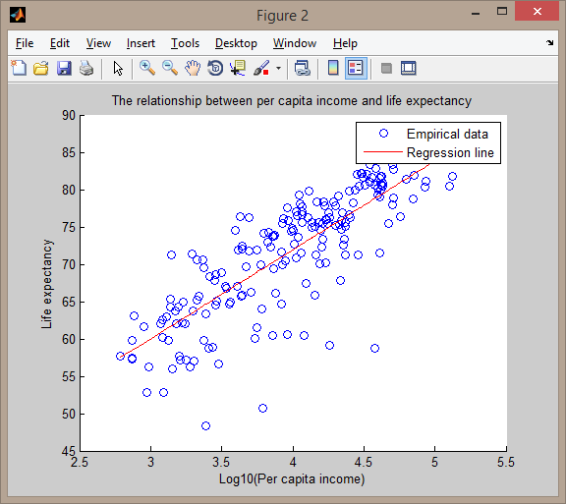

% SST SSE S R^2
le_mean = mean(le);
et2 = (le - le_mean).^2;
SST = sum(et2);
'SST'
disp(SST);
e2 = (le - y_le).^2;
SSE = sum(e2);
'SSE'
disp(SSE);
S = sqrt(SSE/(n-2));
R2=1-SSE/SST;
'R^2'
disp(R2);

'S'
disp(S);

SST
1.2183e+04
SSE
4.3123e+03
R^2
0.6460

Means that 64.6% of the variation of Life expectancy was explained by the model.

S
4.8021

% Std. Error and p-value
lpci_mean = mean(lpci);
lpcir2 = (lpci - lpci_mean).^2;
lpcir2sum = sum(lpcir2);

Sb0 = S*sqrt(1/n+lpci_mean^2/lpcir2sum);
Sb1 = S/sqrt(lpcir2sum);

'Std. Error b0 b1'
disp([Sb0 Sb1]);

't value b0 b1'
t0 = b0/Sb0;
t1 = b1/Sb1;
disp([t0 t1]);

'p-value b0 b1'
pval0=2*(1-tcdf(abs(t0),n-2));
pval1=2*(1-tcdf(abs(t1),n-2));
disp([pval0 pval1]);

Std. Error b0 b1
2.5684 0.6447
t value b0 b1
9.4527 18.4747
p-value b0 b1
0 0
It means that both variables, constant and Log10(Per capita income), are important in the model

